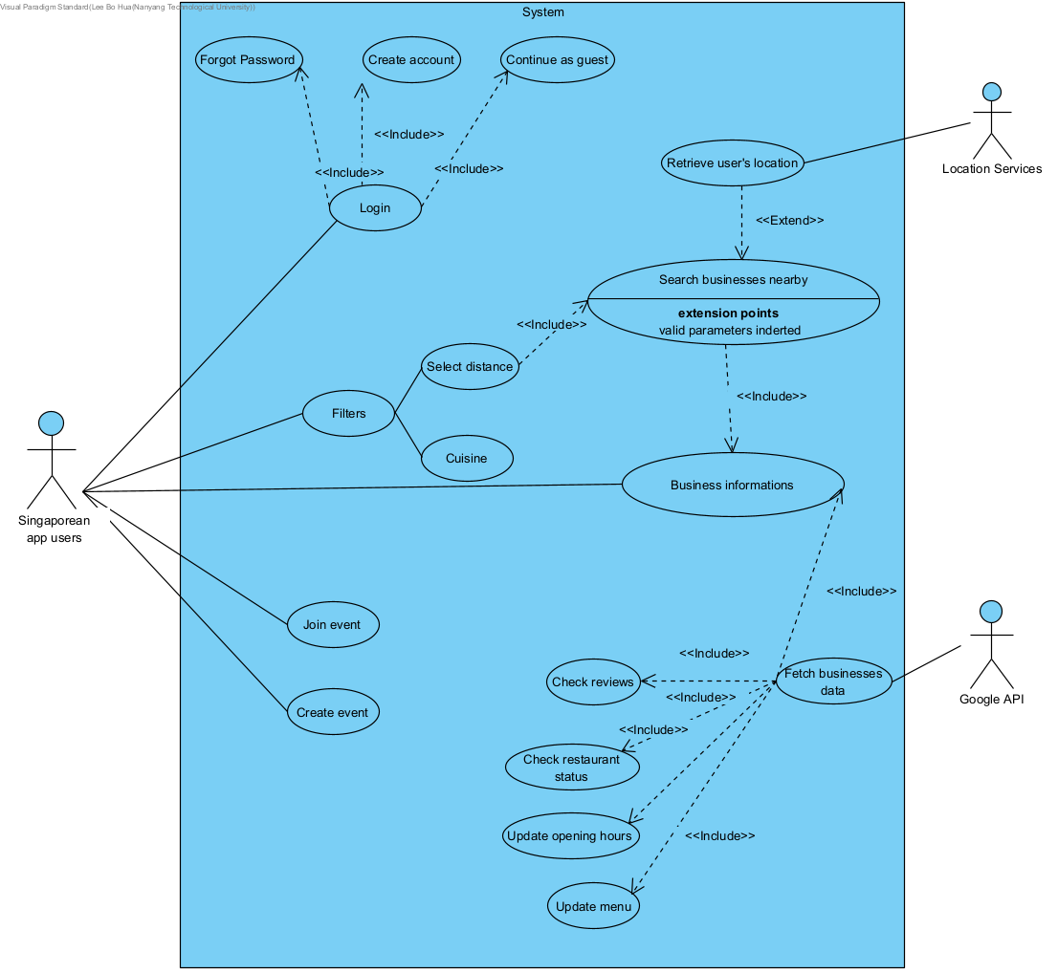

| Use Case ID: | G3001 | | |
| --- | --- | --- | --- |
| Use Case Name: | Search Business Info | | |
| Created By: |  | Last Updated By: |  |
| Date Created: | 26/8/2022 | Date Last Updated: | 31/8/2022 |

| Actor: | Singapore App User |
| --- | --- |
| Description: | This use case allows users to search for information about any restaurant |
| Preconditions: | User’s device should be connected to the Internet  User can only search based on their current location, if location services is enabled on their device |
| Postconditions: | All restaurant that within the defined location range and filters, that matches the search case will be displayed |
| Priority: | High |
| Frequency of Use: | High, upon user’s request |
| Flow of Events: | 1. The user calls this function by    1. Entering the name, description, or location of their desired restaurant through the search bar       1. Can adjust the filter based on their preference, which affects search results       2. The user clicks on the “Current Location” button in search bar          1. A request access to the user’s location service will be sent 2. All restaurant within the defined location range and filters, that matches the search case will be displayed, with order based on how close it matches the search parameters, and proximity to user’s location (if enabled) |
| Alternative Flows: | G3001 .AC. 1:  Step 1.1.1 – No restaurant can be found based on user’s search parameters   1. A pop-up toast message that shows “No results found” will be displayed 2. (Can consider auto increase radius??) |
| Exceptions: |  |
| Includes: |  |
| Special Requirements: |  |
| Assumptions: | User’s device have enough memory to launch the app  Browser supports our application |
| Notes and Issues: | Ajax application  Debounce/Throttle (increase loading speed) |

| Use Case ID: | G3002 | | |
| --- | --- | --- | --- |
| Use Case Name: | Create Event | | |
| Created By: |  | Last Updated By: |  |
| Date Created: | 26/8/2022 | Date Last Updated: | 30/8/2022 |

| Actor: | User |
| --- | --- |
| Description: | This use case allows for users to create an event based on a particular Restaurant, such that their friends can join |
| Preconditions: | User’s device should be connected to the Internet  Able to execute G3001: Search business info, and have already successfully searched a restaurant  User have an account and is signed in |
| Postconditions: | An event will be created and displayed to other users |
| Priority: | Medium-Low |
| Frequency of Use: | A few times a week (2-3 times) |
| Flow of Events: | 1. The user should have already searched for a business, and clicked on it for more information 2. User will click on the button “Create Event” 3. User will be prompted for event details    1. Event Name, Visibility, time, duration 4. Event will be successfully created, and |
| Alternative Flows: | GS3002.AC.1:  Step 2 - User is not logged in   1. A dialog box that shows “No results found” will be displayed, with buttons that says “login now” and Cancel    1. If user clicks “login now”       1. They will be re-directed to the login page       2. Once successfully logged in, user will be sent back to step 3 to continue creating the event    2. If user clicks “Cancel”       1. User will be sent back to step 1   GS3002.AC.2:  Step 3 – Time given by user falls outside of Restaurant’s opening hours   1. A dialog box that shows “Time falls outside of operating hours!” will be displayed    1. User will be sent back to Step 3 to adjust the event time |
| Exceptions: |  |
| Includes: |  |
| Special Requirements: |  |
| Assumptions: |  |
| Notes and Issues: | Not a high priority development as not really part of the main function |

| Use Case ID: | G3004 | | |
| --- | --- | --- | --- |
| Use Case Name: | Join Event | | |
| Created By: |  | Last Updated By: |  |
| Date Created: | 26/8/2022 | Date Last Updated: | 30/8/2022 |

| Actor: | Singapore App User |
| --- | --- |
| Description: | This use case allow for users to join an event other users created |
| Preconditions: | User’s device should be connected to the Internet  User have an account and is signed in  Event Visibility is either public or created by user’s friend |
| Postconditions: | User will be part of the event he/she successfully joined  Event creator, and all other user that have already successfully joined the event, will be notified |
| Priority: | Medium-Low |
| Frequency of Use: | A few times a week (2-3 times) |
| Flow of Events: | 1. User click on ‘JOIN’ to join an event that is either public or created by their friend 2. A pop up message saying “You have successfully joined {event name}, which will be held at {event location} on {event time}!” will be displayed |
| Alternative Flows: | GS3004.AC.1:  Step 1 - User is not logged in   1. A dialog box that shows “No results found” will be displayed, with buttons that says “login now” and Cancel    1. If user clicks “login now”       1. They will be re-directed to the login page       2. Once successfully logged in, user will be sent back to step 3 to continue creating the event    2. If user clicks “Cancel”       1. User will be sent back to step 1 |
| Exceptions: |  |
| Includes: |  |
| Special Requirements: |  |
| Assumptions: |  |
| Notes and Issues: |  |

| Use Case ID: | G3005 | | |
| --- | --- | --- | --- |
| Use Case Name: | Log in | | |
| Created By: |  | Last Updated By: |  |
| Date Created: | 26/8/2022 | Date Last Updated: | 31/8/2022 |

| Actor: | User |
| --- | --- |
| Description: | This use case allows user to log into the account |
| Preconditions: | User’s device should have access to Internet  User should have already registered for an account |
| Postconditions: | User’s account is successfully logged in |
| Priority: | High |
| Frequency of Use: | Multiple times |
| Flow of Events: | 1. User will enter their login details (username/email and password)    1. System validates the login by verifying the login details with the database 2. If login is successful, a toaster popup indicating “Login Successful” will be shown 3. User will be brought to the (insert main page) |
| Alternative Flows: | GS3005.AC.1:  Step 1: User choose login via FaceBook or Google   1. (insert whatever API) will be called to verify the login details 2. Return to step 2   G3005.AC.2:  AC1: Facebook/Google account not connected   1. (Wtv API) redirects user to connect their Facebook/Google account 2. Return to step 2   GS3005.AC.3  Step 1.1: Invalid login credentials   1. System detects that login details does not match database records 2. Popup message saying “Invalid username and/or password” will be shown 3. Return to step 1 |
| Exceptions: | GS3005.Ex.1:  Step 2: Login details successfully validated, but user account is banned   1. A toaster popup indicating “Account is banned, please contact {company email} for more information” will be shown 2. Return to step 1 |
| Includes: |  |
| Special Requirements: |  |
| Assumptions: |  |
| Notes and Issues: | Will define how a user is banned in the future? (Can ask if theres anyway we can represent it?) |

| Use Case ID: | G3006 | | |
| --- | --- | --- | --- |
| Use Case Name: | Register | | |
| Created By: |  | Last Updated By: |  |
| Date Created: | 26/8/2022 | Date Last Updated: | 31/8/2022 |

| Actor: | User |
| --- | --- |
| Description: | Account registration |
| Preconditions: | User’s device should have access to Internet  User’s email should not be previously registered before |
| Postconditions: | User’s account is successfully created and added into database |
| Priority: | High |
| Frequency of Use: | Once per user |
| Flow of Events: | 1. User clicks on REGISTER button in the main page to direct to the registration page 2. Users enters this information as prompted in the registration page    1. Username    2. First Name    3. Last Name    4. Password    5. Confirm password    6. Email address 3. User clicks on “Register” |
| Alternative Flows: | GS3006.AC.1.1  Step 3: Username less than 5 characters   1. Dialog box with error message “Username should be atleast 5 characters!” displayed 2. Redirected back to Step 2, but with all previously entered information remaining there   GS3006.AC.1.2  Step 3: Username already in database   1. Dialog box with error message “Username already taken!” displayed 2. Redirected back to Step 2, but with all previously entered information remaining there   GS3006.AC.2.1  Step 3: First or Last name contain Numbers or Special characters   1. Dialog box with error message “First and/or Last Name should not contain numbers or special characters!” displayed 2. Redirected back to Step 2, but with all previously entered information remaining there   GS3006.AC.3.1  Step 3: Password less than 5 characters   1. Dialog box with error message “Password should be atleast 5 characters!” displayed 2. Redirected back to Step 2, but with all previously entered information remaining there   GS3006.AC.3.2  Step 3: Password does not contain atleast 1 number or special character   1. Dialog box with error message “Password should include at least 1 number or special character!” displayed 2. Redirected back to Step 2, but with all previously entered information remaining there   GS3006.AC.4.1  Step 3: Email not in proper format   1. Dialog box with error message “Email not in proper format!” displayed 2. Redirected back to Step 2, but with all previously entered information remaining there   GS3006.AC.4.2  Step 3: Email already in database   1. Dialog box with error message “Email already used!” displayed 2. Redirected back to Step 2, but with all previously entered information remaining there   GS3006.AC.5  Step 3: Any field from 2.1-2.6 is empty   1. Dialog box with error message “Non of the fields should be empty!” displayed 2. Redirected back to Step 2, but with all previously entered information remaining there |
| Exceptions: |  |
| Includes: |  |
| Special Requirements: | 1. Passwords    1. Atleast 5 characters long    2. Must include atleast 1 number or special characters    3. Must be salted with a hashvalue (in the database?) 2. Username    1. Atleast 5 characters long    2. Numbers and special characters are allowed    3. Should not already be in the database 3. First and Last Name    1. Numbers and special characters are not allowed 4. Email Address    1. Must have @ and .    2. Should not already be in database |
| Assumptions: |  |
| Notes and Issues: | * Can consider adding in mobile verification or email verification in the future! |